**IT2120 - Probability and Statistics**

**Senavirathne W.S.S**

**IT24100026**

**Lab Sheet 05**

**Exercise**





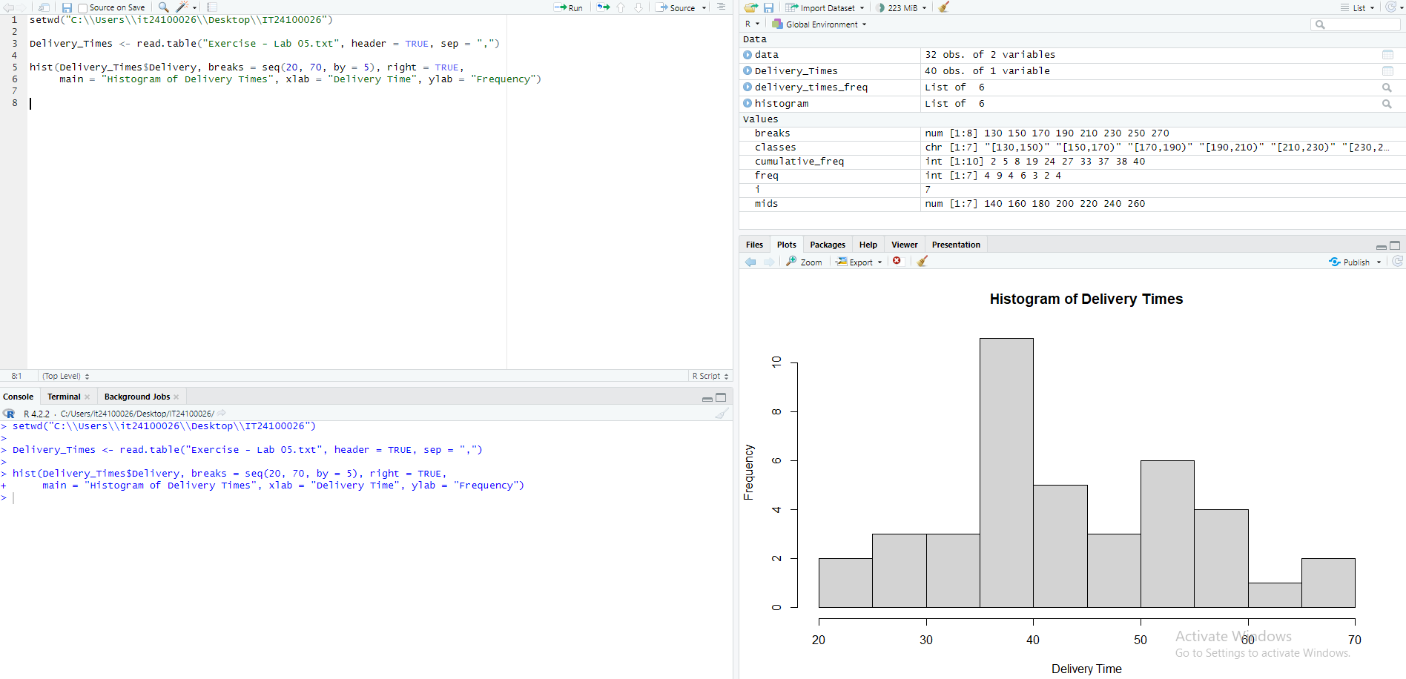



* The distribution is approximately having one clear peak with a peak around 35-40 minutes but shows a slight positive skewness, as the right tail is longer than the left.



